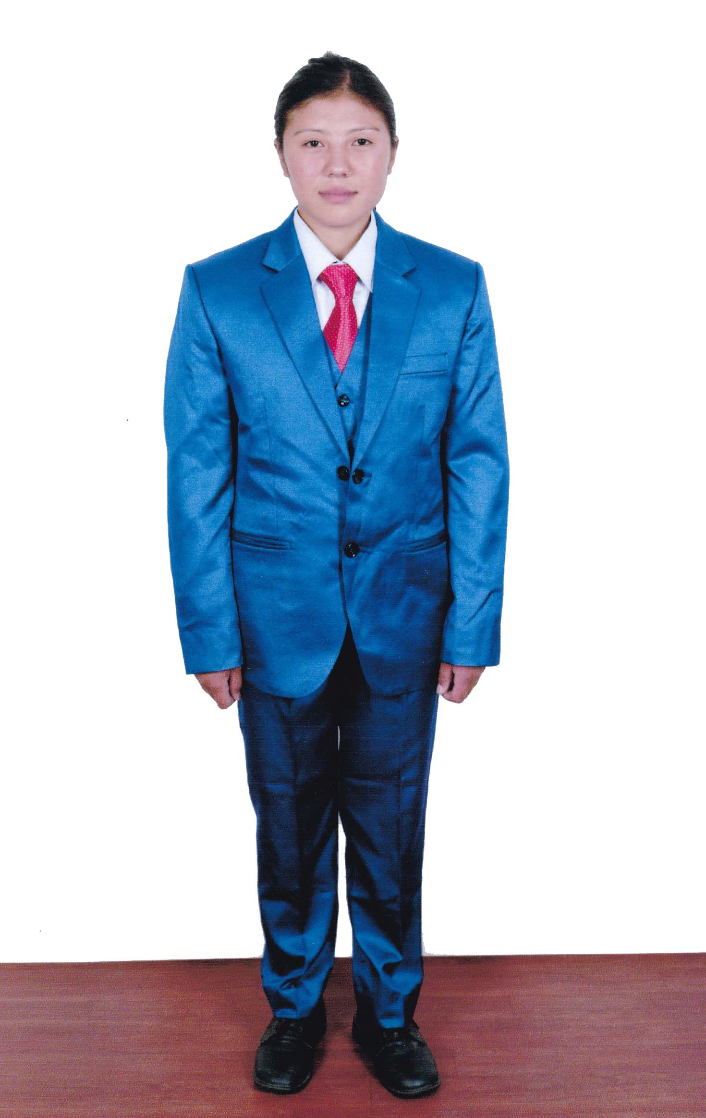
WHOLE BODY PICTURE
KNOWLEDGES IN:  YES|NO |  | PASSPORT SIZE PICTURE
CLEANING | √ | 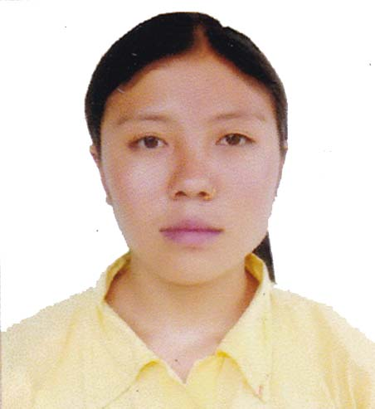
COOKING | √
WASHING | √
IRONING | √
GARDENING | √
SEWING | -
CHILDREN CARE | √
OLD PEOPLE | √
SICK PEOPLE | √
COMPUTER OPER | -
NURSING | -
MASSAGE | -
CAR WASH | -
APPLICATION FOR EMPLOYMENT

OUR REF. No: JAS/759/2022 | DATE: 2022

SURNAME: KULUNG
NAME: LILA
Date of Birth: 23/04/2001 |  |  |  |  |  |  | Place of Birth: Solukhumbu
AGE: 21 Years |  |  |  |  |  |  | Religions: Hindu
ADDRESS: Sotang-02, Solukhumbu
Married: |  |  |  | Single: √ |  |  |  |  | Divorce: |  |  | Widow:
Children No: |  |  |  |  |  |  |  |  | Age:
Passport No: PA0319822 |  |  |  |  |  |  |  |  | Date of Issue: 02/05/2022
Place of Issue: Kathmandu |  |  |  |  |  |  |  |  | Date of Expired: 01/05/2032
Male: |  |  |  |  |  |  |  |  | Female: √
Educational Qualification: +2 Completa
DIPLOMA:
POSITION DESIRED: HOUSE MAID
LANGUAGES YOU CAN SPEAK
 |  | Zero |  |  | Poor | Fair |  |  |  |  | Good |  | Very Good
ENGLISH |  |  |  |  |  |  |  |  |  |  | √
GREEK |  |  |  |  |  | √
WORK EXPERIENCE & WHERE
No | TIME |  |  | PLACE |  |  |  | POSITION
1. | 2 Years |  |  | Hotel |  |  |  | Cleaner
2.

3.

4.

HEIGHT: 150 Cm |  |  |  |  |  |  |  | WEIGHT: 50 Kg
Smoking:  No |  |  | Do you take alcohol:  No |  |  |  |  |  |  | Driving Licence:  No  Categories:
REMARKS:

Contact Telephone: 00977-9866191085
COPY OF PASSPORT | 